**Name: ____________________________ ID: _____________**

**Department of Computer Science and Engineering**

**CSE340: Computer Architecture   
Fall 2013**

**Quiz-2**

**Full Marks: 15 Time: 25 Mins**

1. Draw the missing links? **3**

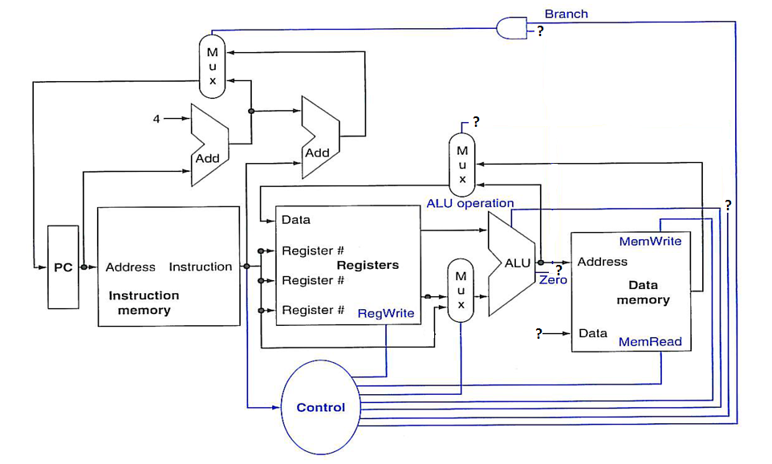

1. What are the advantages and disadvantages of single cycle data path implementation? **3**
2. Following figure shows the datapath for **sw** instruction, label the figure where marked “**?**”. **5**

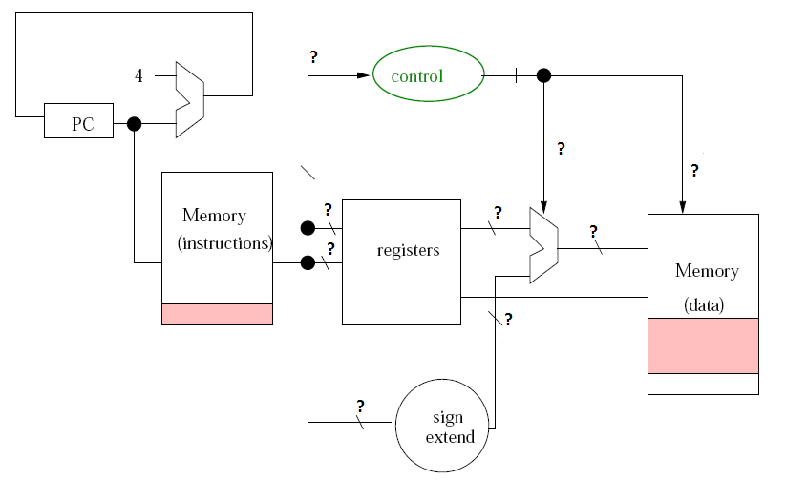

1. For executing lw $16,40($17), circle the appropriate MUX output in the below datapath. 4